Xtreme Reading Micro-credential Overview
XR micro-credentials indicate increasingly deeper levels of learning and practice. The micro-credentials can be earned individually, and subsequent levels can build upon previous levels.

XR PROFESSIONAL LEARNING CREDENTIAL
This credential indicates that the recipient has participated in the Xtreme Reading Institute to learn how to teach the Xtreme Reading Program with students. The XR Professional Developer who led the institute submits a post-professional development report to KUCRL and notifies KUCRL to award the credential.

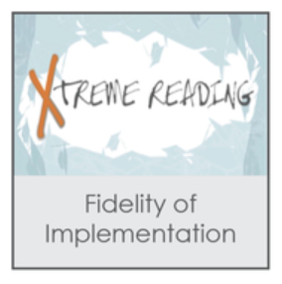
XR FIDELITY OF IMPLEMENTATION CREDENTIAL
This credential indicates that the recipient has instructed students with fidelity through the entire program, created a portfolio to demonstrate impact and proficient implementation with a word level strategy, a reading comprehension strategy, and Xpect to Achieve, created narrative logs about implementation, was observed delivering instruction to students, and demonstrated key behaviors for self-reflection and coaching. The recipient must engage in a coaching relationship with a XR Professional Developer who is active in the SIM network. When all requirements have been met, the XR Professional Developer notifies KUCRL to award the credential.

XR PROFESSIONAL DEVELOPER CREDENTIAL
This credential indicates that the recipient has fulfilled all XR Professional Developer criteria set forth by KUCRL. This credential indicates that the recipient has, under the guidance of a XR Professional Developer as a mentor and XR Professional Development Leader, demonstrated proficiency in instructing others in the use of the Xtreme Reading Program with fidelity, guiding new learner(s) to implement the intervention with fidelity. When all requirements for this credential have been met, the XR Professional Development Leader notifies KUCRL to award the credential. This credential allows the recipient to facilitate professional learning on the XR Program through XR Institutes.

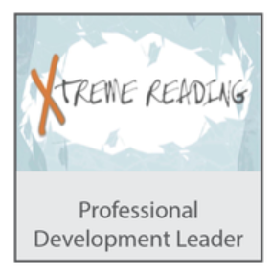
XR PROFESSIONAL DEVELOPMENT LEADER CREDENTIAL – UNDER DEVELOPMENT
This credential indicates that the recipient is credentialed as an XR Professional Developer, is active and current within the SIM Network, and has met the requirements set forth by KUCRL to facilitate professional learning for new XR Professional Develpers.

