AT-A-GLANCE

This document provides information about the structure, Learning Strategies and their purpose, number of daily lessons, and materials included in the Xtreme Reading Curriculum. Xtreme Reading’s spiral curriculum is comprised of eight foundational reading and motivation strategies delivered in a single school year. Xtreme Reading entails explicit instruction in each strategy, guided and paired practice, collaborative learning, meaningful feedback, and independent practice in generalizing and combining strategies within and outside school.
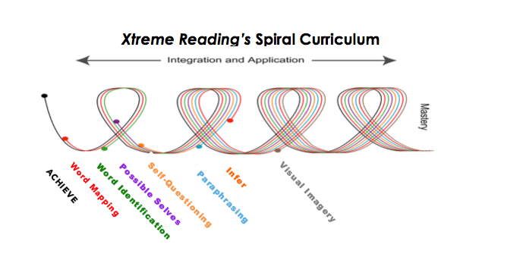

- Xpect to ACHIEVE Notebook – 7 Daily Plans – Built to launch the learning community, course and to provide Teacher Resources, this notebook includes the Course Timeline, Course Launching, Tips for Success, Book Study Guides, Book Vocabulary, Substitute Lesson Plans, and Monitoring Tools.

Lesson/Daily Plan objectives are focused on teachers and students getting to know each other, motivation, clarifying expectations for the course, practicing class procedures for the course, and guidelines for success.

Strategy manual included – Talking Together
Supporting materials - CD
Student Materials – The Xtreme Reading Student Notebook with all practice lessons

- Word Mapping Strategy Notebook – 6 Daily Plans - Students are introduced to the Word Mapping Strategy lessons that introduce prefixes, suffixes, and roots to support vocabulary and comprehension development. Students can learn to master the entire strategy across the year via Start-Up Activities for each reading lesson. Prefixes, suffixes and roots are introduced. The book study activities are introduced and students learn how to engage in the ‘Xtreme’ daily activities.

Strategy Manual included– Word Mapping Strategy
The Xtreme Reading Student Notebook

- Word Identification Notebook – 18 Daily Plans - Students learn the Word Identification Strategy to learn an efficient, functional strategy to decode and identify unknown words in their reading materials.

Strategy Manual Included – Word Identification Strategy
The Xtreme Reading Student Notebook; Word Identification Practice Reading Passages

- Possible Selves Notebook –6 Daily Plans - Possible Selves is designed to increase student motivation by having students examine their futures and think about goals that are important to them. Students set goals, create plans, and work toward their goals.

Strategy Manual Included – Possible Selves
The Xtreme Reading Student Notebook

- Self-Questioning Strategy Notebook – 25 Daily Plans – In the Self-Questioning Strategy students learn how to intentionally engage their minds in reading. They learn to ask themselves a question, make a prediction as to the answer to the question and then read on to find the answer. They learn how to activate their minds to better focus while reading, thus improving understanding. Lessons and practice with previously learned strategies take place.

Strategy Manual Included – Self-Questioning Strategy
The Xtreme Reading Student Notebook; Self-Questioning Practice Reading Passages

- Paraphrasing Strategy Notebook – 44 Daily Plans – Students are instructed in specific lessons in Fundamentals of Paraphrasing and Summarizing and then the Paraphrasing Strategy. Focused first on paraphrasing words, phrases and main ideas and details, students then learn how to read short passages, identify the main idea and details and rephrase the content into their own words. Students practice responding to comprehension questions about their reading. Lessons and practice with previously learned strategies take place.

Strategy Manuals Included – Fundamentals of Paraphrasing and Summarizing, Student Lessons, and the Paraphrasing Strategy
The Xtreme Reading Student Notebook

Strategy Integration and Generalization – 7 Daily Plans - Word Mapping, Word Identification, Self-Questioning, and Possible Selves lessons are included during this instructional unit, and all strategies are practiced in concert through Book Study.

- Inference Strategy Notebook - 35 Daily Plans - With the Inference Strategy, students learn to make inferences about information they have read and answer inferential questions. They learn to identify key words in questions or invent their own questions to help them search for important information in reading passages; determine the type of question they need to answer; think about what they already know about a topic; find clues in the reading passage that will help them answer the questions; look for additional information and answer the question. Lessons and practice with previously learned strategies take place.

Strategy Manuals Included – the Inference Strategy, Inference Strategy Student Lessons
The Xtreme Reading Student Notebook

- Visual Imagery Strategy Notebook – 23 Daily Plans – The Visual Imagery Strategy is a reading comprehension strategy for creating mental movies of narrative passages. Students visualize the scenery, characters, and action and describe the scenes to themselves as they read each sentence. Students use the strategy to improve their understanding and recall of specific facts and sequences. Lessons and practice with all previously learned strategies take place.

Strategy Manual Included – Visual Imagery Strategy
The Xtreme Reading Student Notebook; Visual Imagery Practice Reading Passages

For more information about Xtreme Reading or the Strategic Instruction Model:
Email: simpd@ku.edu
Call: 785-864-4780

