Accelerating Student Growth through the Strategic Instruction Model: Effective for Decades, Needed Now More Than Ever

July 8, 2021

Rosemary Tralli, Ph.D., SIM Professional Development Leader

Jocelyn Washburn, Ph.D., Director of Professional Development, KUCRL
Across the country, educators seek viable instructional options as they navigate what some are calling the new normal or schools reimagined. Schools anticipate that many students will not be prepared to meet current grade level expectations after many months of remote and blended instruction during the pandemic. Traditional remediation may be a great source of support for many children. However, educators are concerned that many students may never “catch up” if all prior learning gaps are remedied before addressing grade level learning. A balance of interventions is required. Remediation of prior critical content and skills, coupled with strategies that support mastery of current curriculum, will maximize student learning. Toward that end, acceleration is a recommended approach.
Acceleration prepares students to achieve grade level expectations through strategic planning and instruction. The process readies students for new learning and remediates select gaps that are purposeful to current or future learning. Acceleration is not a method to move students more quickly through the curriculum. Instead, acceleration ensures that instruction of critical content is deepened or enhanced.
Instructional tools and interventions within the Strategic Instruction Model (SIM™) support remedial and accelerated approaches to close learning gaps. For example, Learning Strategies, one arm of SIM, are recognized for their efficacy and results over decades of school-based implementation as means to empower learners, especially adolescents. This article will illustrate the specific applications of Content Enhancement Routines, the other arm of SIM, and the SMARTER Instructional Cycle as a solution to the educational challenge facing teachers today: how to accelerate learning.

Acceleration Planning and Instructional Practices
Acceleration emphasizes instructional conditions that help students meet grade level learning demands through real-time address of high priority needs. High student engagement and continual instructional adjustments are based on student data. Intervention varies based on the unique profile and needs of each student. The definition of acceleration is elaborated in Table 1 through characteristics that are always, sometimes, or never present when acceleration is actualized.

Table 1. Characteristics of Acceleration
ALWAYS | SOMETIMES | NEVER
Determine critical content | Focus on essential concepts | Provide isolated skill/drill
Identify and fill in high priority needs | Relate to standards | Support instruction that is irrelevant to the curriculum
Provide high engagement activities | Develop key vocabulary | Pre-teach with same activities as in core class
Support real-world relevance | Develop key skills
Conduct formative assessment/feedback | Pre-teach to build pre-requisite knowledge and skills
Ensure teacher collaboration

Planning for Acceleration
Accelerating learning for all students begins with a plan. TNTP (2020; formerly known as The New Teacher Project) has narrowed the focus for teacher planning to these five recommended actions:
- Prioritize MOST CRITICAL content by grade level and content area
- Identify prerequisite skills and vocabulary needed to access critical content
- Determine diagnostic measures to diagnose student learning gaps in the prerequisites
- Adapt the scope and sequence
- Determine who and where to provide accelerated support
Moreover, research on teacher planning shows it is not a discrete set of tasks to complete entirely before instruction begins. Therefore, the SMARTER Instructional Cycle, which emerged from more than 30 years of research conducted at the University of Kansas Center for Research on Learning (KUCRL), represents the dynamic nature of how effective teachers plan, teach, and evaluate in academically diverse classrooms (Bulgren & Lenz, 1996). Figure 1 shows the steps in the SMARTER Instructional Cycle.

Figure 1. The SMARTER Instructional Cycle
Shape critical questions that are aligned with standards
foundational, permeating, persisting questions drawn from standards that guide teaching and learning
Map critical content & relationships
visual representation of the critical questions; shows organization of the content, concepts, and thinking skills required to learn standards
Analyze critical content & relationships to design assessments
consideration of student needs, difficulty of content, and access to higher level thinking
Reach instructional enhancement decisions
selection of simple and complex enhancers to make learning understandable and memorable; use of specially designed instruction
Teach strategically
application of the Cue-Do-Review instructional sequence and explicit instruction, partnership learning and interactive dialogue to guide learning
Evaluate learning
formative assessment to provide feedback to students on their learning and to teachers on the effectiveness of instruction
Revisit learning outcomes and critical questions
adjustments in response to formative assessment in a timely manner related to mastery of critical content

The SMARTER Instructional Cycle begins by examining an entire course. In consideration of the first four steps—SMAR, research on course planning showed that when teachers more fully predicted the types of routines, strategies (learning and social), communication systems, and accommodations that they felt addressed the difficulties in learning, then they were more likely to implement instructional innovations than teachers who did not engage in this type of course to unit to lesson planning. These same teachers continued to update and refine their decisions throughout course instruction through formative evaluation. Additional research shows that mapping the organization of key concepts and the type of thinking required to learn the concepts influences how well students can learn to think about the information in the standards. Specific SIM Content Enhancement Routines, the Course Organizer Routine and the Unit Organizer Routine, are designed to prompt the use of these steps and to visually record decisions that are shared with students, colleagues, and parents.
Student Engagement and Voice for Learning
“From another perspective, each of the [SMARTER] steps shown also represent various opportunities to engage students in various forms of academic communication about learning. The evolution to the use of practices linked to providing more collaborative, co-constructed types of learning experiences rests on a teacher’s ability to engage students as part of the completion of each of these instructional steps. Students can/must be enlisted to participate in conversations about critical questions, the structure of information, why learning is difficult, how learning difficulties can be addressed, how to improve teaching, their perceptions of progress towards achieving learning outcomes, and how to participate in actions related to improving results of summative assessments.” –Keith Lenz, 2016

Accelerated Instruction
Accelerated instruction calls for strategic teaching and learning conditions that are met through SIM Content Enhancement Routines:
- Stimulate thinking
- Develop concrete models
- Introduce important content vocabulary
- Learn essential academic vocabulary
- Scaffold to address gaps in understanding
- Introduce new concepts just prior to the acquisition of new learning
- Look to access and make connections to prior knowledge
- Form predictions
- Provide frequent formative assessments
Content Enhancement Routines (CERs) help educators to teach purposefully and strategically based on students’ needs to master critical content. The instructional process is met through the TER steps of the SMARTER Instructional Cycle. Research showed students were able to comprehend and recall critical content at significantly higher levels when these routines were integrated into classroom instruction (Fisher & Schumaker, 2021; Schumaker & Fisher, 2021). The routines provide the deep conceptual learning, higher order thinking, mastery of essential vocabulary and content, and high task engagement that are key to acceleration. As illustrated below, the CERs provide significant resources to ensure student success in meeting grade level learning expectations.

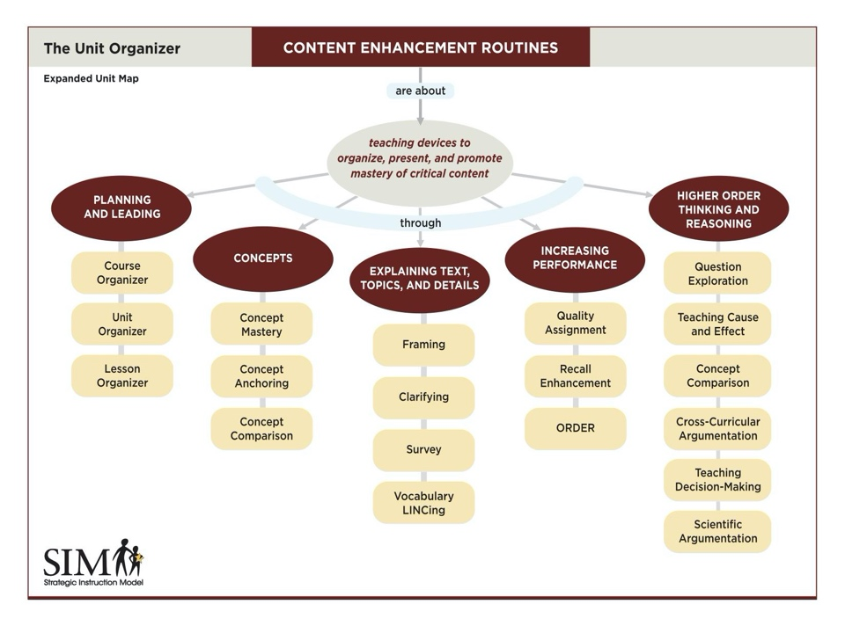
Figure 2. Map of SIM Content Enhancement Routines

Based on the structure of course content, teachers select a routine to optimize instruction. For example, when teaching critical concepts, the Concept Mastery, Concept Comparison, and Concept Anchoring Routines support deeper understanding through use of direct vocabulary instructional techniques, such as elaborated definitions and examples/non-examples. A routine is used to support the learning process, promotes high student engagement, and deepens student understanding. This “toolbox” of resources allows educators to teach strategically, evaluate learning in real-time, and adjust instruction accordingly.
Each CER offers a unique visual organizer that illustrates key relationships. Students co-construct the organizer with teacher facilitation to promote high engagement, activate prior knowledge and focus on important content. Formative assessments are conducted throughout the process to scaffold instruction as needed and to determine the need for re-teaching. The responsive planning, teaching, and assessment adaptations embedded in the Content Enhancement Routines are hallmark conditions of acceleration. Through these steps, all students are guaranteed equitable learning conditions and outcomes because their instruction is enhanced to address their unique learning profiles and skills.

Be Prepared, Inspired, and Ready to Act
Researchers, educators, policymakers, and others concerned with using prior research to make decisions for today’s challenges suggest high-dosage tutoring as the most effective way to help students catch up. Other structures have been promoted too, such as extended day and summer programs. These recommendations encourage teachers to spend more instructional time with students, but they do not give ideas for how to spend that time. Furthermore, these recommendations require more time to be available. Since needs will vary among schools and students, having a strategic approach to planning and delivering instruction, in any condition, is key. SIM Content Enhancement Routines and SMARTER provide timely, cost-effective, and practical tools to accelerate student learning.
For more information, visit www.sim.ku.edu. To connect with a SIM Professional Developer or have a conversation about how SIM may meet your school or district needs, email simpd@ku.edu.

References
Bulgren, J.A., & Lenz, B.K. (1996). Strategic instruction in the content areas. In D.D. Deshler, E.S. Ellis, & B.K.
Lenz (Eds.), Teaching adolescents with learning disabilities: Strategies and methods. (2nd ed., pp. 409- 473). Denver, CO: Love Publishing.
Lenz, B.K. (2016). The SMARTER instructional cycle. [White paper]
Fisher, J. B., & Schumaker, J. B. (2021). 35 years on the road from research to practice: A review of studies on four Content Enhancement Routines for inclusive subject-area classes, Part II. Learning Disabilities Research and Practice.
Schumaker, J. B., & Fisher, J. B. (2021). 35 years on the road from research to practice: A review of studies on four Content Enhancement Routines for inclusive subject-area classes, Part I. Learning Disabilities Research and Practice.

